**University of Redlands**

**School of Education**

**Teaching Credential Success vs Undergraduate GPA**

*Wendy McEwen, Assistant Provost for Institutional Research*

The School of Education Retention and Graduation Rate Working Group is interested in understanding the patterns of success for students enrolling in the post-undergraduate teaching credential program. One aspect which we are exploring is whether or not the student’s undergraduate GPA has an impact on success.

Datatel contains undergraduate GPAs for 834 of the 1005 new teaching credential students (83.0%) enrolled in the School of Education teaching credential program from Fall 2007 through Fall 2012. These 1005 students do not include College of Arts & Sciences students who have substantially completed their teaching credential while undergraduates (a.k.a. “Drop Ins”). Chart 1 below is the histogram of these 834 students versus their undergraduate GPAs.

**Chart 1: Number of Newly Enrolled CTC students versus their undergraduate GPA**

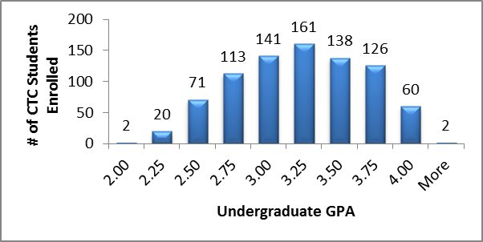

As you can see from the chart, 93 of the students enrolled in the CTC had undergraduate GPA’s of 2.50 or less (11.2% of the 834 students). This group of students was retained to the 2nd semester at a rate of 74.2%. For those students with undergraduate GPA’s above 2.5, the rate of retention to the 2nd semester was 80.6%.

While the difference of over 6% for retention is interesting, it is more interesting to look at the graduation rates for these students. Chart 2 below shows these 834 students with their graduation status as of June 2013. For the % Graduated calculation, if a student has completed all School of Education teaching credential coursework (“Courses Complete”) they are included in the % Graduated. As you can see, those students who enroll in the teaching credential program with less than a 2.50 undergraduate GPA have substantially less likelihood of reaching a teaching credential. Overall, the graduation rate for those CTC students with less than

a 2.50 undergraduate GPA is 59.1% versus 72.1% for those who enroll with a greater than 2.50 undergraduate GPA.

**Chart 2: Number of Newly Enrolled CTC students versus their undergraduate GPA and whether or not they graduated**



Another way visualize this data is using a boxplot. A boxplot is a graph where the total number of data points is divided into quartiles (25% of the data). Each quartile is represented by a different section on the boxplot. The longer each section of the boxplot is, the more variation there is in the data which encompasses that quartile (25%). Chart 3 has the boxplots of the undergraduate GPA versus the student’s graduation status. As you can see, the undergraduate GPAs for the students who receive their teaching credential are slightly higher than those who have not received a credential. The 1st quartile value for the graduating group is approximately the same as the median for the not graduating group.

**Chart 2: Boxplot of CTC students versus their undergraduate GPA and whether or not they graduated**

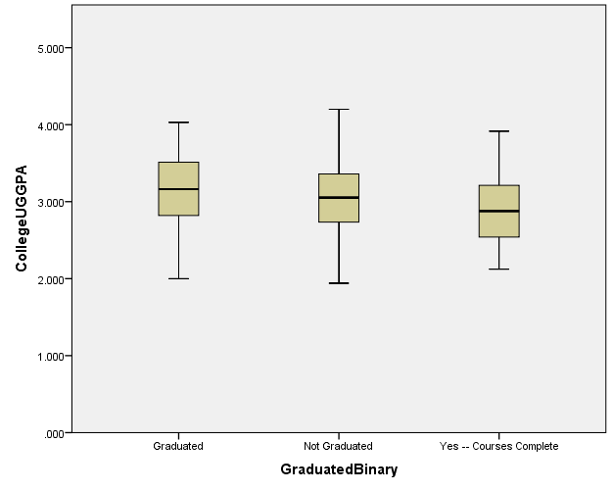

Median

Median

3rd Quart.

Median

1st Quart.

While a 60% graduation rate isn’t horrible, the data seems to show that a student has a much better chance of success if their undergraduate GPA is over 2.50. Interestingly, teaching credential students enrolling with undergraduate GPAs between 2.50 and 3.00 seem to have the same success as those who enroll with undergraduate GPAs above 3.00.

Disaggregating student success by Preliminary Service Credential (PSS) or Multiple Service Credential (PMS) also provides us a different view of student success. Chart 3 shows the number of teaching credential students who were not retained by GPA along with the graduation rate for this same group. While the total number of not-retained students for the PSS is higher, this degree also has a higher enrollment than PMS – 56% to 44% for the studied group. There does seem to be a difference in graduation rates by the two degree types, though. For CTC students with less than a 2.5 undergraduate GPA, the graduation rate for PMS students is 72.8% versus 65.4% for PSS students.

**Chart 3: Teaching Credential Success versus Undergraduate GPA**

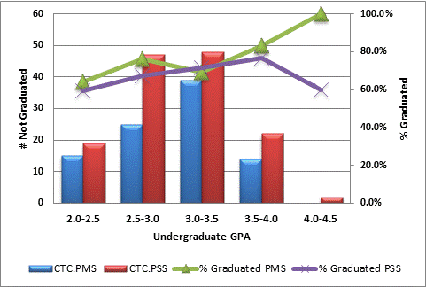

**Next Steps**

As the School of Education Retention and Graduation Rate Working Group continues to explore aspects of student success, we are looking forward to identifying other characteristics which have an impact on retention and graduation rates. The team is working on updating a credential “road map” to help students through the multi-step process of obtaining a credential. We are also exploring other ways of guiding students through the process including the development of an app. The discussion on undergraduate GPA and student success has provided insight to the admissions and academic leadership which will help focus our incoming applicants and provide them better guidance and support as they seek to become teachers.