**College of Arts & Sciences**

**First Time Full Time Entering Freshmen  
Transfer Out Student Graduation Rates**

*Wendy McEwen, Director of Institutional Research*

Graduation rates are important in higher education, not only as a method of comparing institutions but as a focus of accreditation. The most commonly used graduation rate metric is the number of First-Time Full-Time Entering Freshmen who start at one school and complete a degree at the same school within 150% of their expected graduation time – the 6 year graduation rate. This rate does not take into account those students who transfer to another institution and subsequently graduate.

According to a recently published study by the National Student Clearinghouse Research Center and Indiana University, one third of all students transfer at least once before earning a degree (Hossler, Feb 2012). Thus, tracking students after they transfer is becoming increasingly important in order to more fully contextualize student success.

Over 92% of U.S. students attend colleges participating in the National Student Clearinghouse (NSC) system (Student Clearinghouse, 2012). Using the NSC, we are able to track student persistence and completion rates for College of Arts & Sciences students who are no longer enrolled in the College.

Examining the transfer out behavior for the College of Arts & Sciences First-Time Full-Time Entering Freshmen for Fall 2005, Fall 2006, and Fall 2007 shows very similar behavior to that found in the NSC study. Of the 569 students from these three cohorts who are no longer enrolled and have not graduated from Redlands, the NSC has subsequent enrollment information on 412 (72%). For these 412 students:

* 57% Transferred prior to their 2nd year
* 27% Transferred prior to their 3rd year
* 7% Transferred prior to their 4th year
* 8% Transferred after they were enrolled in fall of their 4th year

Not only are students transferring to another institution, many attend more than two colleges or universities in pursuit of their degree. Graphic 1 presents the break-out of schools attended for our group. As an outlier, one student has attended 8 subsequent institutions after Redlands – that student has not yet been awarded a degree.

**Graphic 1: Number of Schools Attended**

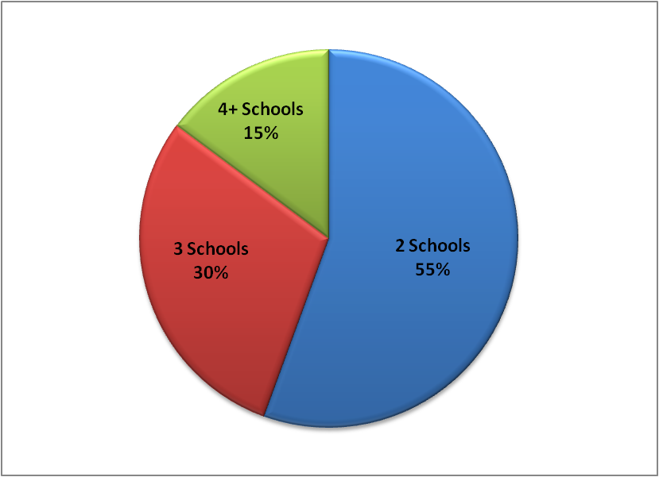

The types of schools to which students initially transferred varied. Less than half of the students remained in California (185 of the 412). Ninety-nine (24%) students transferred to another private institution. One hundred fifty-eight (38%) transferred to a public 2-year institution. One hundred fifty-five (38%) transferred to a public 4-year institution.

Of the 412 transfer out students, 163 have been awarded a bachelor’s degree as of January 1, 2012. While many students 45% did attend more than 2 schools, 82% of those students who have completed their undergraduate degree were awarded degrees from the first school to which they transferred.

For the degrees awarded, 75 were awarded from private schools and 88 from public schools. Graphic 2 lists the schools which awarded degrees to more than one Redlands student.

**Graphic 2: Degree Granting Schools**



Graphic 3 gives the break-out of the degrees awarded.

**Graphic 3: Degree Awarded**

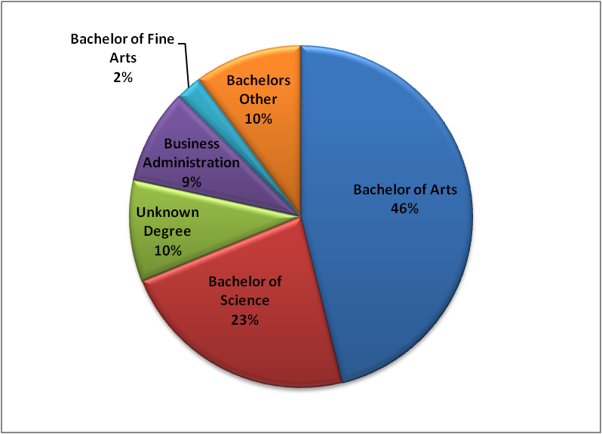

While the graduation rate metric continues to be the internal 6-year graduation rate for First-Time Full-Time Entering Freshmen, we can also include the graduation information for those students who were awarded degrees from other institutions. Graphic 4 provides the detail of both our reported 6-year graduation rate as well as the adjusted graduation rate using NSC data.

**Graphic 4: Cohort Completion Rates**



For the Fall 2005 cohort, the 6-year graduation rate is final. The Fall 2006 cohort’s rate will be finalized August 2012. The Fall 2007 cohort’s rate will be finalized August 2013.

As we continue to focus on improving our students’ success, it will be useful to better understand their patterns of enrollment. As noted in the National Student Clearinghouse study, these patterns are becoming more complex nationwide. “The results suggest that the linear view of college access and success that focuses on the initial institution attended often fails to address the realities on the ground” (Hossler, 2012, pg. 6).

**References**

Hossler, D., Shapiro, D., Dundar, A., Ziskin, M., Chen, J., Zerquera, D., & Torres, V. (February 2012). *Transfer and Mobility: A National View of Pre-Degree Student Movement in Postsecondary Institutions.* National Student Clearinghouse Research Center and Indiana University. Herndon, VA.

*How the Clearinghouse Can Help You (n.d.).* National Student Clearinghouse. Retrieved from <http://www.studentclearinghouse.org/colleges/files/VSA_Handout.pdf> May 9th, 2012.