University of Redlands
College of Arts & Sciences Retention Working Group
Findings and Recommendations
April 2012
Executive Summary
- The Retention Working Group detailed the diverse retention efforts already in place in the College of Arts & Sciences in its April 2011 paper. It is the group’s opinion that these efforts are effective. A retention rate of 84% is an achievable goal. However the long-term goal of increasing our average 1st to 3rd semester retention rate to 87% was submitted in the April 2011 paper along with action items necessary to achieve that goal.
  - The next section of this paper provides in detail progress on these action items.
  - Highlights include a continued focus on students at risk through a variety of Student Life Programs, the successful initial year for the Male Mentor program, and a focus on tutoring efforts in partnership with the Academic Success Center.
- The Fall 2010 First-Time Full-Time Entering Freshmen cohort 1st to 3rd semester retention rate was 87.3%. This is the highest retention rate in several years.
  - The increased rate is a result of the combined efforts of many initiatives throughout the College as well as a reflection of the large number of Cal Grant students in the Fall 2010 cohort. Cal Grant recipients were 25% of this group.
  - Cal Grant students are retained and graduate at a higher rate than non Cal Grant students. If the proposed cut to the Cal Grant program is implemented, the impact on College retention rates and graduation rates will be significant.
  - As an update to our current retention and graduation trends for the College First-Time Full-Time Entering Freshmen cohorts, see Graphics 1 and 2.

Graphic 1: First-Time Full-Time Entering Freshmen 1st to 3rd Semester Retention Rates

Graphic 2: 4 Year and 6 Year Graduation Rates for First-Time Full-Time Entering Freshmen

*The Fall 2006 Cohort 6 Year Graduation Rate is projected as of March 2012
** The Fall 2008 Cohort 4 Year Graduation Rate is projected as of March 2012

- During the 2011-2012 academic year, the Retention Working Group has largely focused on understanding our graduation rates.
  - One important aspect of this has been to gain an understanding of why some students who are very close to graduating do not complete all necessary requirements. Often, the unfulfilled requirements are related to administrative processes versus academic course work.
    - These “gap” students are receiving additional attention from the Registrar as well as individual attention from Working Group members.
    - The goal of this additional focus is to help students understand the requirements and encourage them to complete the requirements in a timely manner.
    - Faculty play a large role helping students complete all graduation requirements. The Retention Working Group feels that providing opportunities for faculty involvement would help encourage their participation, positively impacting retention and graduation rates. See Recommendations #2 for more detail on this proposal.
  - The Registrar is playing a critical role in helping the group understand the graduation requirement process. The Office of the Registrar is requesting funding for an additional position. This position will work with faculty, Student Life, and students identifying those who are close to graduation but not complete and helping these students navigate the degree completion requirements. See Recommendations section #4 for more detail on this need

Progress Report on Retention Rate Action Items from April 2011
- Continue to work collaboratively with the College of Arts & Sciences Office of Admissions in identifying characteristics which are more likely to result in successful students as defined by retention and graduation.
  - This item remains in status as an on-going focus of both the Office of Admissions as well as the Retention Working Group.
- Providing an increased budget for tutoring for the Academic Success Center.
  - Received $8000 permanent enhancement in 2011-2012 to accommodate the increased need for tutors.
  - Finding appropriate tutors from within the College undergraduate population is challenging. See the Recommendations section # 1 for additional recommendations enhancing this initiative.
- In Fall 2010, a pilot for the College Persistence Questionnaire (CPQ) was initiated. For Fall 2011, this program was extended to all entering freshmen.
  - First-year seminar faculty were encouraged to have students take the CPQ during weeks 6-8 of the fall term. The faculty were also asked to attend a training learning to interpret the results of an individual student’s CPQ, use the results in advisor-advisee interaction, and how to recognize the need for and the process of referring a student for intervention. Of the 36 first-year seminar instructors, 10 attended the training. Because of this low faculty participation, the CPQ effort had a diminished data collection and intervention impact.
  - Eliminating mandatory faculty training, the administration of this program has been modified in preparation for the 2012-2013 academic year. Student Life will play a larger role, providing support for the students as well as the advisors.
- Twenty-eight (28) students completed an eight hour training in order to become volunteers for the I’m Going To College (IGTC) and Native American Student programs. Of these, 26 are Cal Grant students, 25 are First Generation.
- Fourteen (14) students are serving as mentors in our Supporting, Educating and Empowering Diverse Students (SEEDS) program. This program is currently partnered with the AVID program at Hemet High School. Of these students, 12 are First Generation students.
- Seventy (70) students enrolled in the two-credit Students Together Empowering Peers (STEP) program in the fall, of which 45 were mentees and 25, mentors. In the spring, there are 45 students registered. In order to be a Summer Bridge mentor, students are required to be registered for the spring STEP course.
- The high cost of text books has been identified as a barrier to academic success. Many students in the College have a very limited budget and were struggling with this.
  - The Campus Diversity and Inclusion Center (CDI) has a book lending program. This lending program began as a small initiative to match students who couldn’t afford books with students who had previously taken that particular class. However, it has become increasingly obvious that a number of students are unable to purchase all required books. Many are able to purchase a percentage of them and have to make a difficult choice as to which books not to buy.
  - In 2010, CDI began to think more comprehensively about this issue and came to the conclusion that a structured Book Lending Program would move toward a goal of all students having the books they needed. We are aided in this by the interest of a number of alumni who generously provided the seed money for this program.
  - In addition, the Patricia and Christopher Weil Family Foundation have underwritten book purchases for Summer Bridge students for the past two years.
  - In the 2011-2012 academic year:
      - There were 75 participants in the fall (63 of them Cal Grant students, one is from the Reality Changers Program) and 53 in the Spring (48 of them Cal Grant recipients and again one is from Reality Changers).
      - 57 Summer Bridge students utilized the program. All are Cal Grant recipients; approximately 45 are First Generation students.
- As in most colleges and universities, male students are more at-risk in the College of Arts & Sciences. Focusing on this group, a Male Mentor Program has been initiated.
  - A group of male student life administrators and faculty members has met weekly since September, 2011 implementing a plan for increasing male student engagement. Programming has included: Weekly “Man Talks” in the Campus Diversity and Inclusion Center (CDI), increased promotion of intramural and outdoor programs to male students, a planned men’s leadership retreat, and extensive discussion on how to make campus activities, events, and environment more male-friendly.
  - The impact of these interventions has been to identify a core group of undergraduate men who will assist the Male Mentor Program administrators during the 2012-2013 academic year. One focus will be with first-year students. Four of the administrator/faculty from the program will be teaching first-year seminars, placing them in a position to address the retention issues that incoming first year male students face.
  - Going forward, increased attention toward male students will include “men’s only” programming at orientation and at CDI during the school year, fall and spring retreats for undergraduate male leadership, increased availability of athletic facilities for non-collegiate athletics, surveying of the incoming class of men on preferred activities, targeted programs to first year men based on survey data, outdoor backpack trips geared to appeal to men, early identification and student life intervention in the residence halls of non-engaged men, and targeted intervention with men who are struggling academically.
  - The metric of success for the mentorship program will be benchmarked based on male first-time full-time entering freshmen retention from Fall 2012 to Fall 2013.
  - As an administrative enhancement to this initiative, the Retention Working Group recommends creating a job description and stipend for a program director. See recommendations section #4 for more detail on this recommendation.
  - See the Recommendations section #4 for additional recommendations on this initiative.
- The Working Group requested that the University work at more clearly defining the College of Arts & Sciences. This request has been met by the creation of a University Peer Group.
- To accommodate the increase in Intramural Sport participation, the Working Group recommended an additional graduate student. This recommendation was implemented with funding provided through Student Services.
- The Working Group recommended hiring 3 part-time academic scheduling advisors. This request was tabled for 2011-2012 pending additional research and consideration.

Focus on Graduation Rates
In April 2011 the College of Arts & Sciences Retention Working Group proposed that the group examine opportunities for improvement in the four year and six year graduation rates for the First-Time Full-Time Entering Freshmen cohorts.
- An important aspect of researching graduation rates as a measurement of student success has been developing an understanding around the definitions of cohorts and the progression of students.
  - The most commonly reported retention and graduation metric only includes students who started at a specific college of university as First-Time Full-Time Entering Freshmen and graduated from that same school in 150% of the expected time to graduation.
  - For most programs, 4 years is the expected time to graduation, resulting in a commonly-reported 6 year graduation rate.
  - If a student takes a leave of absence from the College, they are not counted as retained. If the student returns to the same school after completing a leave of absence and subsequently graduates, that student is included with their original entering cohort.
  - It is important to note that students who started as freshmen in the College of Arts & Sciences but transferred and graduated from another institution are not included in this rate.
  - At some point soon, Institutional Research will have the ability to research and report on degree attainment rates for those students who were not retained using the National Student Clearinghouse database. This reporting access will enable the College of Arts & Sciences to better articulate the number of students who graduate overall, even if they did not graduate from the College of Arts & Sciences.
- To help visually illustrate the progression of a First-Time Full-Time Entering Freshmen cohort, Institutional Research created a graphic for the Fall 2007 First-Time Full-Time Entering Freshmen cohort. Graphic 3 below updates the graphic for the Fall 2008 First-Time Full-Time Entering Freshmen cohort. Note that the graduation rate is PROJECTED as of mid-March, 2012.
  - For the Fall 2008 cohort, the projected four year graduation rate of 65% is a 2% increase over the Fall 2007 First-Time Full-Time Entering Freshmen cohort four year graduation rate.

Graphic 3: First-Time Full-Time Entering Freshmen progression – Fall 2008 Cohort
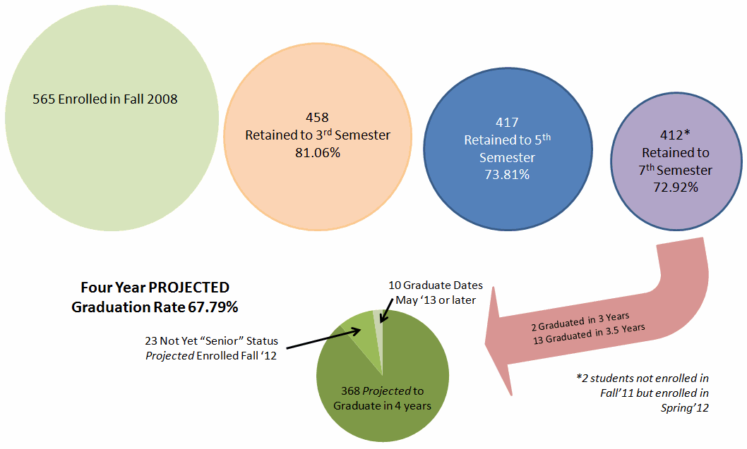
- One significant focus for improving graduation rates has been to work with the Office of the Registrar, identifying those juniors and seniors who are not making satisfactory progress towards gradation. This focus has included several initiatives:
  - National studies have shown that students with declared majors are more likely to be retained and to graduate. To that end, one focus of the Registrar’s Office in partnership with faculty advisors is to encourage students to declare a major by the end of their sophomore year.
    - Helping increase access to the administrative portion of the process, the Registrar has published the declaration of major form online. The form can be completed online and sent electronically to the academic department chair for signature. The department secretaries then send the signed copy to the Registrar’s office.
    - The Registrar’s Offices is attending the Grad Fair each spring. This helps provide on-site feedback to students who have questions about the majors and minors declaration process.
    - The Registrar now institutes a “hold” on the ability of a student to register for classes once they have reached the 64 credit classification level unless the student has declared a major. If a sophomore has not yet declared a major, he or she receives an email prior to both of their subsequent registration periods encouraging declaration.
  - Copying advisors on all communication with their advisees. This includes communication with advisors at the beginning of the graduation review process.
  - Implementing a system of graduation checks occurring during a student’s junior year, versus their senior year. This is helping identify and address problems and concerns earlier.
  - Streamline reporting on those students that did not graduate. This includes detailed use of communications remarks screens in Datatel. Details include specific outstanding requirements for graduation. Letters are mailed to the student by mail and an email correspondence is also sent.
  - Identifying, reporting, and robust tracking of “gap” students. “Gap” students are those students who were enrolled during their 7th semester, the beginning of their senior year, but did not graduate by the end of the 8th semester.
    - In early Fall 2011, the Retention Working Group identified 64 “gap” students from the Fall 2007 First-Time Full-Time Entering Freshmen cohorts as well as 34 students from this same cohort who were enrolled at the beginning of their 9th semester – 5th year.
    - These students were contacted by the Registrar as well as Working Group members, encouraging them to complete all requirements for graduation.
    - 140 “gap” student files for cohorts from 1996 through 2009 have been reviewed by the Registrar this year. Of these 140, 68 students have subsequently completed all graduation requirements and been awarded degrees.
    - The Associate Registrar has largely taken on the responsibility to identify, track, and counsel “gap” students. In order to continue to focus on this initiative, funding for an additional person is requested. See Recommendations section # 4 for additional detail on this need.

Recommendations
- Continue the focus on tutoring to improve student success – retention and graduation
  - Graphic 4 outlines the current trend and projected need for additional funding and personnel for tutoring. The graphic shows the number of tutors in the Office of Academic Success (past 2.5 years) versus the number of subject tutor requests received. Note that one Administrator is assigned to manage the tutoring operations for the University, as well as address probationary concerns.
  - For 2012-2013, an additional tutoring concern is that the number of declared math majors, the primary source for tutoring, is decreasing. Even if an adequate tutoring budget exists, the College needs to find alternatives for appropriate advisors for math and science tutoring to meet the increasing need.
    - One potential proposal would be hiring local graduate students to provide tutoring.
    - Another possible solution could be to work with the School of Business pool of tutors to help meet the needs of the College.
Graphic 4: Number of Tutors vs. Tutor Request

  - Graphic 5 shows the term over term increase in the number of tutoring sessions. The fall semester increases are primarily due to students needing assistance in introductory math, chemistry, and biology courses. Math and science tutoring have increased significantly since the 09-10 academic year with the number of sessions hitting over 2000 sessions total last year. With the increase in tutors, the Academic Success Center will offer over 2500 sessions by the end of this academic year.
Graphic 5: Tutoring Sessions Increasing

- Increase opportunities for interested faculty to get involved in addressing issues of retention.
  - A potential model could be the individually focused aspects of the Faculty Interaction Program.
  - Action Items for implementing this initiative would include creating a faculty advisory group.
    - This group would be responsible for identifying and further training interested faculty
    - Creating opportunities, particularly for junior faculty, to count such involvement as ‘Service’, for Review purposes
    - Providing a budget which could be used for ‘checking in’ with students over coffee or lunch. (Budget similar to the Diversity Affairs first-generation students check in allocation.)
- Provide funding for an additional student assistant position in the Registrar’s Office. This student would help administratively research and track “gap” students as well as provide detailed information regarding degree completion requirements for juniors and seniors. The amount of funding requested for this position is $2100.

