**University of Redlands**

**College of Arts & Sciences**

**Male Undergraduate Retention and Graduation Rates**

*Wendy McEwen, Assistant Provost for Institutional Research*

**Retention and Graduation Rates**

Like many liberal arts institutions, the College of Arts & Sciences enrolls a larger number of women than men as College of Arts & Sciences undergraduates. Between Fall 2003 and Fall 2013, the percentage of new, First-Time Full-Time Entering Freshmen who are men has varied between 37% and 47% of the entering class. As well as having lower enrollment numbers, the College’s 1st to 3rd semester retention rate for men has also consistently been lower. While the difference between the women’s and men’s retention rates has varied over the last ten years, the average difference in the rates between these groups is 5%. Table 1 shows the retention for both groups.

**Table 1: 1st to 3rd Semester Retention for College First-Time Full-Time Entering Freshmen**

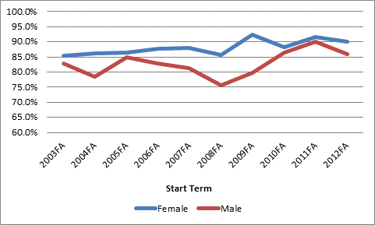

Looking at graduation rates for those First-Time Full-Time Entering Freshmen beginning in Fall 2003 through Fall 2009, male students also graduate at a lower rate than their female peers. As with the 1st to 3rd semester retention rate, the difference between the graduation rates varies cohort by cohort. For the students starting in Fall 2003 through Fall 2009, the average difference between the female and male graduation rate is 10%. Table 2 shows the graduation rates by gender.

**Table 2: Graduation Rates College First-Time Full-Time Entering Freshmen**

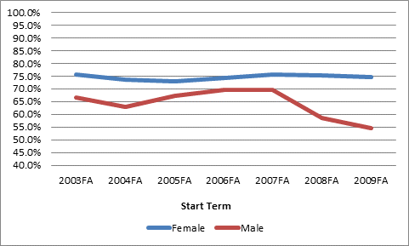

As you can see on in Table 2, the men’s graduation rates for the Fall 2008 and Fall 2009 cohorts are significantly lower than that of the women. It is important to note that we most often report graduation rates at 150% of time, which is a six year rate. The Fall 2008 and Fall 2009 groups have not yet reached this six year mark, and it isn’t unusual to have 30 or more men and 20 or more women graduate in five to six years. Thus, we do anticipate the graduation rates to increase for these cohorts.

The reasons a student might take longer than four years to graduate vary. Some might have taken a Leave of Absence in order to pursue other interests. Others might have completed their fourth year and need to meet only one or two requirements in order to complete their degree. The College of Arts & Sciences Retention and Graduation Working Group is actively discussing this topic and has identified different areas of improvement to help ensure these students graduate within six years.

**Male Characteristics**

If we define one aspect of men’s academic success as being retained and graduating, we can identify some characteristics which make a difference. In the College of Arts & Sciences, one of these characteristics is if a student is a rostered athlete. Beginning with the 2005 Fall cohort, we’ve tracked the retention and graduation rates for athletes. For First-Time Full-Time Entering Freshmen men enrolling between Fall 2003 and Fall 2012, men who were rostered athletes during their freshmen year were retained at an almost 6% higher rate. For the Fall 2003 through Fall 2009 cohorts, the graduation rate is more than 9% higher than that for non-rostered athletes. See Table 3 for this breakdown.

**Table 3: Men’s Retention and Graduation Rates for Rostered and Non-Rostered Athletes**



Another characteristic which has an impact on student success is whether or not a student initially auditioned for the School of Music, regardless of whether or not the student became a music major. Table 4 has the retention and graduation rates for these two groups.

**Table 4: Men’s Retention and Graduation Rates for Music Applicants and Non Music Applicants**



Participation in athletics and music are examples of activates which allow students to engage outside of the purely academic experience. Student engagement is one factor which has a positive impact on a student’s success – students who are engaged are more likely to be retained and to graduate.

In addition to engagement, student demographics can have an impact on student success. One type of demographic information we collect is whether or not a student considers himself a Legacy Student. Most often, this means that the student has a parent or an older sibling who has attended the University of Redlands. Male Legacy Students have higher success rates than Non-Legacy Students. Table 5 has the retention and graduation rates for these two groups.

**Table 5: Men’s Retention and Graduation Rates for Legacy and Non Legacy Students**



Another demographic factor which has an impact on male student success is where the student is from. Table 6 has the retention and graduation rates for male students from California or from out of state. In State students are more likely to be retained and much more likely to graduate than those from out of state. While it is difficult to generalize, we anecdotally know that many students who are not retained transfer to schools

closer to home. Thus, we’d expect to see a higher retention rate for those students for whom the Redlands area is home.

**Table 6: Men’s Retention and Graduation Rates for In State and Out of State Students**



Another aspect of a student’s experience which we can examine is the financial one. We know that financial aid has an impact on retention and graduation rates. While we have many different ways to measure financial aid, receiving the Cal Grant is one which we’ve identified is significant in student success. Table 7 has the retention and graduation rates for those male students who receive Cal Grants and those who do not.

**Table 7: Men’s Retention and Graduation Rates for Cal Grant and Non Cal Grant Students**



In additional to these student characteristics, how students respond to survey questions such as those on the Higher Education Research Institute’s Cooperative Institute of Research Program (CIRP) Freshmen Survey (TFS) can be used to help identify students who may be more at risk. For instance, if a student responds on the survey that the College of Arts & Sciences was less than his third choice, he is slightly more at risk for not being retained to the 3rd semester. Interestingly, if the College was his first, second, or third choice there is little difference in retention rates. If a student is identified as more at risk, intervention by Student Life, an Academic Advisor, or a Coach can help decrease the likelihood the student will not be retained.

**Conclusion**

Male, First-Time Full-Time Entering Freshmen at the College of Arts & Sciences are retained and graduate at a lower rate than their female counterparts. However, there are aspects of student engagement, student demographics, and other student experiences which we can identify as having a positive impact on male students’ success. As we continue efforts to understand student patterns and help the community focus on student engagement and achievement, we hope to see improvement in student retention and graduation rates.