**University of Redlands**

**College of Arts & Sciences Post-Graduate Survey**

**Classes of 2008 and 2012**

*Wendy McEwen, Assistant Provost for Institutional Research*

Graduates of the College of Arts & Sciences Classes of 2008 and 2012 were surveyed in July, 2013. The survey was developed by Institutional Research and Career Services with input from other University departments and distributed via Survey Monkey. See Appendix A for the survey instrument.

The goals of this survey included contacting graduates who are one year and five years post-graduation asking questions about employment, graduate school, and satisfaction with their University experience. We conducted a similar survey in summer 2011 with the Classes of 2006 and 2010. The responses from both these surveys are helping inform our curriculum development as well as student services in the coming years.

***Class of 2008 Responses***

Four hundred three (403) undergraduates from the College of Arts & Sciences Class of 2008 are active in our alumni database. However, of these 403, only 368 have provided the University valid email addresses. Ninety-seven (97) of the graduates responded to our survey. These results represent 24.1% of the overall active students from this class. For the 368 graduates who received our electronic survey, the response rate was 26.4%. Seven of the 97 respondents were Johnston graduates.

**Employment Status**

Increasing emphasis is being placed on employment as a measurement of student success. The results of this survey show that 72.2% of the Class of 2008 are employed full-time including 1 graduate serving in the military. Another 14.4% are enrolled in graduate school. See Chart 1 for the employment status detail.

**Chart 1: Class of 2008 Employment Status**

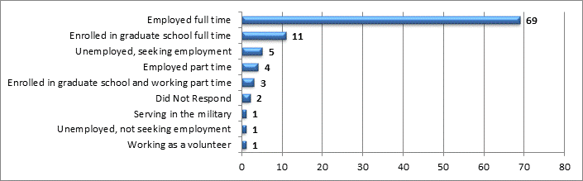

See Chart 2 for the response to “How well do you feel your experience at the University of Redlands prepared you for your current job?”

**Chart 2: Class of 2008 Job Preparedness**

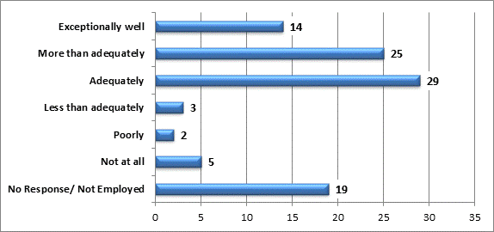

For the group who is employed, when asked if they are employed in a field related to their University of Redlands degree, 29 responded “Yes” and another 22 responded “Yes – Somewhat.”

**Chart 3: Class of 2008 Employment Related to Degree**

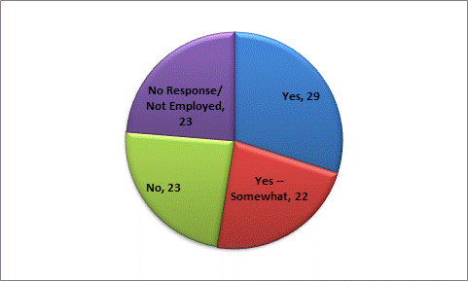

Seventy-eight (78) of the 88 graduates who reported they were working at least part-time responded to our request for salary information. For these 78 graduates, the median salary range is $40,000 - $50,000 with 33 making $60,000 or more. This is a very similar distribution to the survey results from the Class of 2006’s 5 year graduation survey conducted in the summer of 2011.

Twenty-three (23) Class of 2008 graduates responded “No” to the question, “Are you employed in a field related to your University of Redlands degree?” For this group, 8 have attended graduate school. Nineteen of these 23 rated their University experience “Good” or “Excellent.”

We also asked the respondents to tell us how many full-time jobs they have had since graduating from the College. In five years, 16.5% have had three or more full-time jobs. This is slightly lower than the Class of 2006’s rate of 21% with three or more full-time jobs after 5 years.

Overall, responses to the employment-related questions indicate that College of Arts & Sciences graduates from the Class of 2008 are using their undergraduate education and value their undergraduate experiences.

**Graduate School**

Thirty-nine (39) of the 97 respondents say they have been enrolled in graduate school – 40.2%. This number is in line with the independent reports we’ve received from the National Student Clearinghouse regarding post-undergraduate enrollment in higher education.

Thirty-four (34) respondents report they have been awarded graduate degrees including 2 PhD’s, 5 JD’s, 1 MD, 1 MFA, and 2 Doctor of Physical Therapy degrees.

**Internship Responses**

Twenty-two (22) of the respondents from the Class of 2008 participated in internships while at the University. Of these graduates, 19 felt that the internship helped prepare them for their job experiences after graduation adequately or better. The internships in which they participated varied greatly, as did the student’s method of identifying internships. The majority of the students found their internships using their own network of family and friends. Six (6) graduates found internships through their academic department. As with prior class responses, those graduates who participated in internships had a higher median income than for those graduates who did not participate in an internship.

**Positive Experiences**

Each of the respondents was asked the question “If you could begin again, would you attend the University of Redlands?” Forty-three (43) of the 97 respondents said “Definitely Yes” and 31 said “Probably Yes” for a positive rating of 76.3%. While still high, this positive rating is 10% lower than the Class of 2006’s positive responses. Seven (7) graduates responded “Probably No” or “Definitely No” to the “begin again” question.

At this time, we only have 2 years of survey data to compare – the survey conducted in summer 2011 and the survey conducted in summer 2013. It is difficult to draw any significant conclusions about a drop in student satisfaction with only these two data sets. But graduate satisfaction should be closely monitored as we continue to conduct surveys of graduates at one year and five years post-graduation.

Responding to another question, 57 of the 97 graduates said that they would recommend the University of Redlands to others “Without Reservation” which is a rate of 58.8%. Again, 10% lower than the Class of 2006’s 68% response to this question.

Cross-tabbing the responses to the two questions about satisfaction gives us a little more information.

**Chart 4: Class of 2008 Satisfaction**



Another question asked “Overall, how would you rate this school for the time in which you were attending?” Fifty-seven (57) of the 97 respondents rated the University as “Excellent,” which is 58.8%. Another 29 respondents rated the University as “Good,” which is 29.9%. Below is a table of these responses cross-tabbed with the first declared major awarded to the graduate.

**Chart 5: Class of 2008 Overall University Rating by First Declared Major**



**Level of Satisfaction Responses**

Graduates were asked to use a 5-level Likert scale to rate their satisfaction with a variety of programs and services offered by the University. Below are the responses for each of the questions. The responses are displayed two ways: first, by the number of responses for all selections, and second, by the percentage when the No Opinion/No Responses are excluded from the denominator. Overall satisfaction is fairly high. On the low end, 27% of those responding to the question rated their satisfaction with Career Planning and Placement Services as Dissatisfied or Very Dissatisfied while only 12% responded that they were Very Satisfied with this service. While 10% were Dissatisfied or Very Dissatisfied with Academic Advising, 72% were Satisfied or Very Satisfied with advising.

***Chart 6: Class of 2008 Satisfaction Responses***



***Chart 7: Class of 2008 Percentage of Responses by Question* excluding *No Opinion / No Response***



***Class of 2012***

Three hundred seventy-six (376) undergraduates from the College of Arts & Sciences Class of 2012 are active in our alumni database. Of these 376, 308 have provided the University valid email addresses. Eighty-three (83) of the graduates responded to our survey. These results represent 21.1% of the overall class. For the 368 graduates who received our survey, the response rate was 26.9%. Eight of the 83 respondents were Johnston graduates.

**Employment Status**

One year after graduation, only 47.0% of the Class of 2012 is employed full-time. Another 19.3% are enrolled in graduate school. See Chart 8 for the employment status detail.

**Chart 8: Class of 2012 Employment Status**

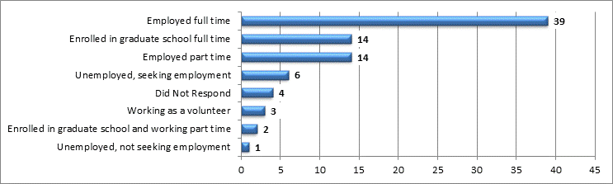

Chart 9 shows the response to “How well do you feel your experience at the University of Redlands prepared you for your current job?”

**Chart 9: Class of 2012 Job Preparedness**

For the 58 graduates who are employed or working as volunteers, when asked if they are employed in a field related to their University of Redlands degree, 16 responded “Yes” and another 17 responded “Yes – Somewhat.”

**Chart 10: Class of 2012 Employment Related to Degree**

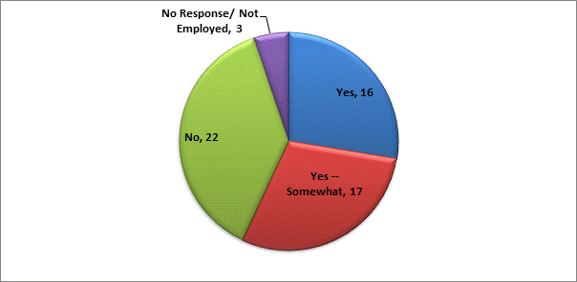

All 55 graduates who reported they were working at least part-time responded to our request for salary information. For these 55 graduates, the median salary range is $20,000 - $30,000 with 12 graduates making $40,000 or more. The salary distribution for the Class of 2012 is slightly lower than the Class of 2010’s when surveyed one year after graduation.

Twenty-two (22) graduates responded “No” to the question, “Are you employed in a field related to your University of Redlands degree?” However, 21 of these 22 rated their University experience “Good” or “Excellent.”

**Graduate School**

Twenty (20) of the 83 respondents report they are currently in graduate school. One additional graduate reports that he had attended graduate school but is not currently enrolled. This is a 25.3% enrollment rate within one year after graduation.

**Internship Responses**

Thirty (30) of the respondents from the Class of 2012 participated in internships while at the University. Of these graduates, 22 felt that the internship helped prepare them for their job experiences after graduation adequately or better. As with the Class of 2008, the internships in which they participated varied greatly, as did the student’s method of identifying internships. Again, the majority of the students found their internships using their own network of family and friends. Five (5) graduates found internships through their academic department.

**Positive Experiences**

Each of the respondents was asked the question “If you could begin again, would you attend the University of Redlands?” Forty (40) of the 83 respondents said “Definitely Yes” and 25 said “Probably Yes” for a positive rating of 78.3%. Eight graduates were uncertain with 4 responding “Probably No” or “Definitely No.”

Responding to another question regarding recommending the University to others, 57 of the 83 said that they would recommend the University of Redlands to others “Without Reservation” which is a rate of 68.8%. See Chart 11 for the cross tab of these responses.

**Chart 11: Class of 2012 Satisfaction**



Below is a table of the responses to the question “Overall, how would you rate this school (for the time in which you were attending?” cross-tabbed with the first declared major awarded to the graduate.

**Chart 12: Class of 2012 Overall University Rating by First Declared Major**



**Level of Satisfaction Responses**

As with the Class of 2008, 2012’s graduates were asked to use a 5-level Likert scale to rate their satisfaction with a variety of programs and services offered by the University. Below are the responses for each of the questions. The responses are displayed two ways: first, by the number of responses for all selections, and second, by the percentage when the No Opinion/No Responses are excluded. On the low end 29% of respondents rated their level of satisfaction with Personal Counseling Services as Dissatisfied or Very Dissatisfied. Career Planning and Placement Services also received ratings at a fairly high level of dissatisfaction.

***Chart 13: Class of 2012 Satisfaction Responses***



***Chart 14: Class of 2012 Percentage of Responses by Question* excluding *No Opinion / No Response***



**Conclusion**

Overall, this survey provides us some broad feedback and statistics with student employment. While salaries are perhaps not as high as we’d like, our graduates largely report employment in fields related to their degrees.

Between the survey administered in the summer of 2011 and the survey from this past summer, there is a slight decrease in satisfaction with aspects of the University of Redlands. We anticipated conducted this survey again next summer, which will provide a better distribution of responses to determine if satisfaction is actually decreasing.

Responses from individual majors will help inform program review, combined with responses from the Higher Education Research Institute’s Senior Survey. If you are interested in more detailed information about this survey, please contact Institutional Research.

**Appendix**

**Survey Instrument (Hard Copy)**

UNIVERSITY OF REDLANDS

**2013 Career Services Survey for 1 year and 5 year graduates**

**Name: _____________________________________________________________________________________________________**

(last) (first) (middle initial) (Maiden Name - if Applicable)

**Permanent Address: ______________________________ ____________ __________________ _____ ____________**

(street) (apt. #) (city) (state) (zip)

**Permanent Phone:** __________________________ **Permanent Email: _________________________________________**

(cell phone number preferred)

**Employment Questions**

**Did you complete an internship/s during college?**  Yes  No

Internship name, employer and location**: ___________________________________________________________________________**

How did you find this internship/s?  Academic Dept.  Career Serv. Listing  Other:_______________________

**How do you feel this internship helped prepare you for your job experiences after graduation?**

Exceptionally well  More than adequately  Adequately  Less than adequately  Poorly  Not at all  NA

**Which one of the following best describes your primary employment status at this time?** (check only one box)

Enrolled in Graduate School full-time  Enrolled in Graduate School part-time  Working as a Volunteer

Enrolled in Graduate School part-time and working part-time  Serving in the military  Employed full-time

Employed part-time  Unemployed, seeking employment  Unemployed, not seeking employment  Other

**How many full-time jobs have you had since leaving the University?**   0  1  2  3  More than 3

**If employed, are you employed in a field related to your University of Redlands degree?**  Yes  No

**If employed, what is your current annual salary range?**

$0 - $20,000  $20,000 - $30,000  $30,000 - $40,000  $40,000 - $50,000  $50,000 - $60,000  $60,000+

**How well do you feel your experience at the University of Redlands prepared you for your current job?**

Exceptionally well  More than adequately  Adequately  Less than adequately  Poorly  Not at all

I am not currently employed

**What resources offered by the Office of Career Services have you used? (Check all that apply)**

Alumni Career Network  Online Career Center (Optimal Resume)

Assessments (Myers-Briggs, Strong Interest Inventory)  Peer Career Guides

Career Advising  Programs and Workshops

Career Library  Resume/Document Critique

Graduate School Advising  Other ___________________________________

**Graduate School Questions**

**Are you currently enrolled in graduate school?**  Yes ___________________________________________  No

(school)

**What degree are you seeking? ______________________________________________________________________**

**Have you attended graduate school at any point after graduating from the University of Redlands?**

Yes _________________________________________________ Degree______________________________  No

(school)

**How well do you feel your experience at the University of Redlands prepared you for graduate school?**

Exceptionally well  More than adequately  Adequately  Less than adequately  Poorly  Not at all

I am not currently employed

**If you are not currently or have not yet been enrolled in graduate school, do you plan to attend graduate school within the next five years?**  Yes  No

**Alumni Questions**

**If you could begin again, would you attend the University of Redlands?**

Definitely yes  Probably Yes  Uncertain  Probably no  Definitely No

**Overall, how would you rate this school (for the time which you were attending)?**

Excellent  Good  Average  Poor

**Would you recommend this school to a friend or acquaintance who asked you your opinion?**

Yes, without reservation  Yes, with some reservation  No

**Please indicate your level of satisfaction with the student services / programs offered by the University during the time you attended.**



**How do you stay in touch with what is happening at the University of Redlands?**

Alumni Magazine Facebook  Reunion Group  Other ______________________________