**University of Redlands**

**School of Business**

**Recent Graduates Feedback**

*Wendy McEwen, Assistant Provost for Institutional Research*

The School of Business Class of 2013 was surveyed this summer. The goals of this survey included receiving feedback about student services, gaining a better understanding of our graduates’ employment patterns and how their experiences at the University of Redlands impacted their careers, and gaining feedback on our veterans’ services. The responses received are helping inform internal academic and student services conversations.

The survey questions were developed by the School of Business Retention and Graduation Rate Working Group and distributed via Survey Monkey to both undergraduate and graduate students. Two hundred twenty (220) of the 655 students surveyed responded for a 33.6% response rate. This included 125 students enrolled in graduate programs and 72 students from our undergraduate programs. Twenty-three (23) survey respondents did not provide any contact information so we were not able to classify them as graduate or undergraduate. The respondents were fairly evenly distributed between campuses. The table below has the breakdown by academic level as well as by campus.

**Respondents by Academic Level and Campus**



**Employment Status**

We asked the respondents to characterize their employment status. Most undergraduates, 81.9%, are employed full-time. Even more graduate students, 84.8%, are employed full-time.

**Undergraduate Employment Status**

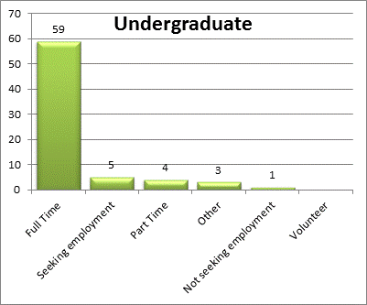

**Graduate Employment Status**

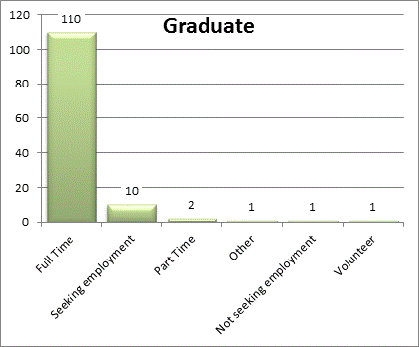

Another employment-related question asked “How relevant do you feel your experience at the University of Redlands has been to your current job?” See the tables below for the responses.

**Undergraduate Academic Experience Relevance to Job**

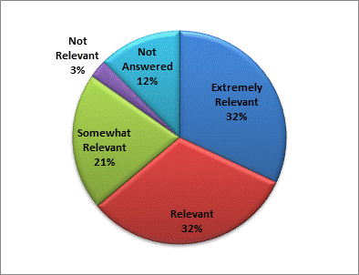

**Graduate Academic Experience Relevance to Job**

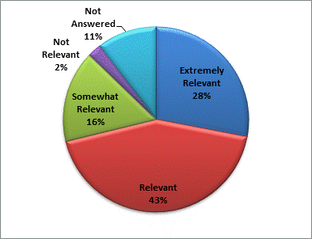

As you can see, the vast majority of students reported that their academic experience was relevant to their current job. Another positive thing we learned from the survey results is that for the undergraduates, 50 of the 72 undergraduate respondents said they have received a promotion or changed jobs since they began at the University. Of these 50, 46 said that their experiences at the University were *Important* or *Very Important* to their promotion or job change.

For the graduates, 99 of the 125 respondents said they have received a promotion or changed jobs since they began at the University. Of these 99, 75 said that their experiences at the University were *Important* or *Very Important* to this promotion or job change.

**Academic Advising Services**

The Retention and Graduation Rate Working Group was very interested in learning more about how our students felt about some of the services the University provided. The graph below provides the responses when asked how useful were the Academic Advising Services at the University of Redlands.

**Undergraduate Usefulness of Academic Advising Services**

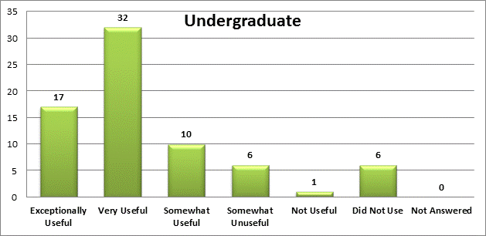

**Graduate Usefulness of Academic Advising Services**

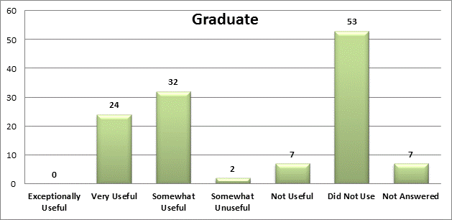

The tables below provide a broader range of responses for the variety of services offered by the School of Business. Overall, if students had experience with the services they were satisfied.

**Undergraduate Student Services Responses**

**Graduate Student Services Responses**

**Additional Items of Interest**

While only 30 military veterans participated in this survey, those that did said that overall, they were satisfied with Veterans Services provided by the University. Fourteen – 46.7% -- said they were very satisfied. Nine – 30.0% -- said they were satisfied. Four – 13.3% -- said they were somewhat satisfied. The remaining three said they did not know Veterans Services were offered.

When asked if the student would recommend the University to a friend or acquaintance, an overwhelming majority said Yes, without reservation or Yes, with some reservation.

**Recommend the University**

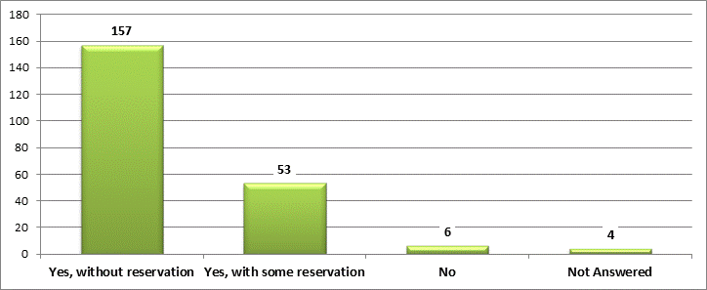

Another indication of the strength of the positive feelings our School of Business graduates have about the University is the way they responded to two questions regarding their overall rating of the school and whether or not they would choose to attend the University again. The table below has the cross-tabbed responses to these questions. One hundred seventy-five of the two hundred twenty students (79.5%) had favorable responses to both of these questions. Only seven (3.2%) had negative responses.



**Next Steps**

This is the first time this survey has been administered to recent graduates of the School of Business. We have been pleasantly surprised at the response rate as well as the feedback we’ve received. While some opportunities for improvement have been highlighted, overall our recent graduates seem very positive about their experiences, the relevant academics, and the overall impression about the University of Redlands.

One important question this survey has raised is “Why do so many not use our services?” Is it because the students don’t know these services exist? Is it possible that the students don’t realize that the interactions they are receiving from counselors are part of these services? The Retention and Graduation Rate Working Group is discussing options for looking at this question more closely.

The Working Group intends to continue administering this survey in coming years. We anticipate using the feedback as part of our continuing efforts to meet students’ need.